Use makes a request fro the resource IIs has ISAPI filter that that decides who will process the request

1. Creation of the environment (code objects like Request, response, context, Application)
2. Processing the request (Page events, handlers, module)

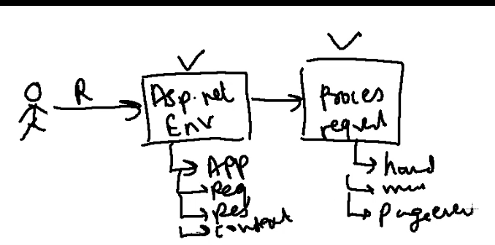

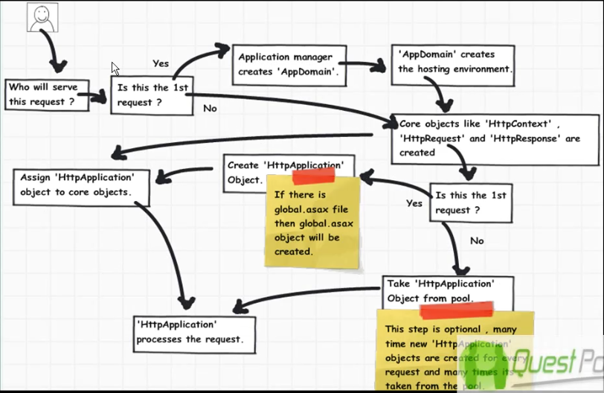

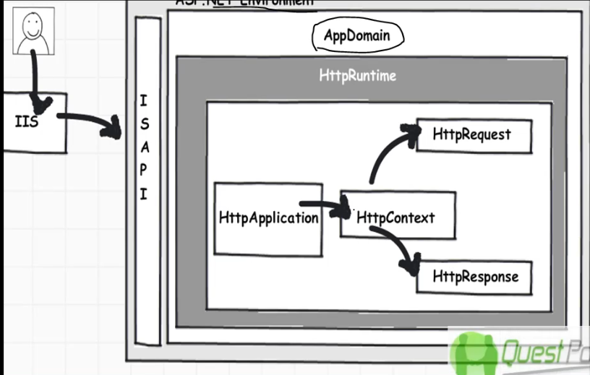

Creation of handler:

Extension based processor

Implement class that extends IhttpHandler and implement ProcessRequest method to inject logic

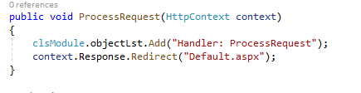

Register:



Handler:

Create a class that implement IHttpHandler then implement the Init method register all events and write injection logic inside these class.

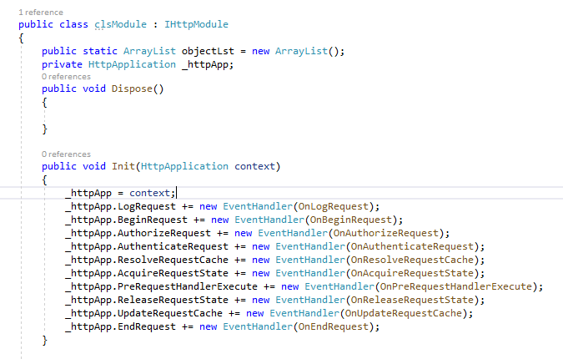

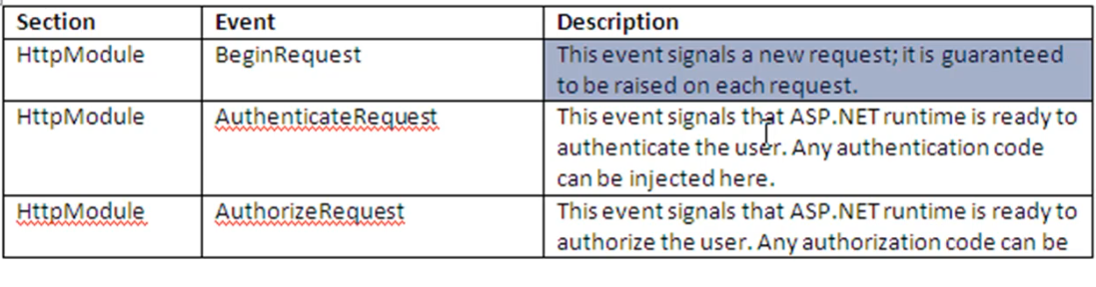

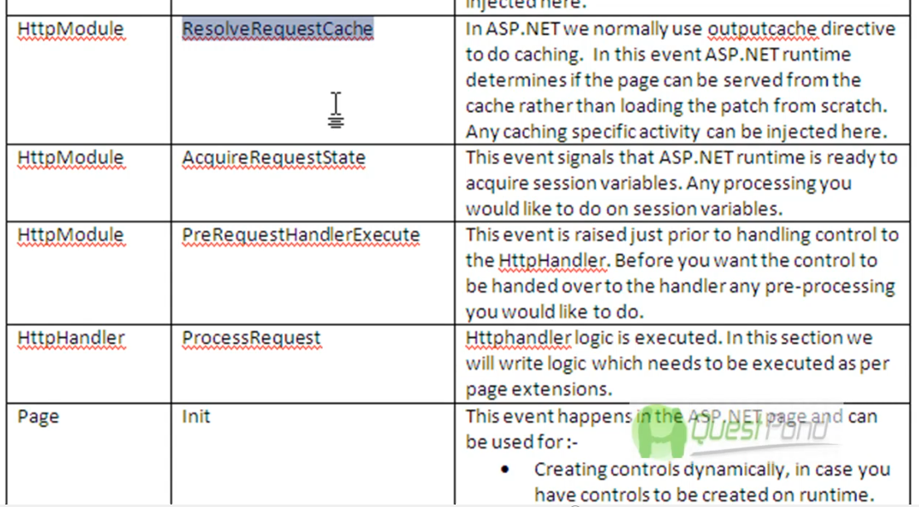

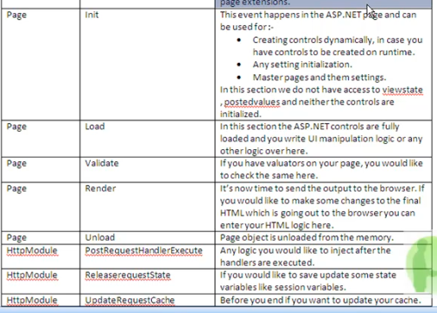

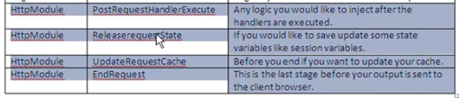

Process:

